Primary Biliary Cholangitis (PBC) Care Bundle
Patient name:
NHS number:
This checklist is designed to aid your patient’s management and guide escalation decisions. Suitability for treatment and surveillance may be considered according to performance status and comorbidity.
Guidance for all domains can be found overleaf.

Please ensure the patient has been signposted to appropriate support groups.

Treat & Risk Stratify
Treated with UDCA? |  | Y | N | Intol
UDCA dosed at 13-15mg/kg? |  | Y | N | N/A
Eligible for second-line therapy? |  | Y | N
Treated with second-line therapy? |  | Y | N | N/A
Actively Manage
Assessed for symptoms? | Pruritus | Y | N
 | Fatigue | Y | N
 | Sicca | Y | N
Osteoporotic fracture risk assessed in the last 5 years? |  | Y | N
Stage & Survey
Disease staged with non-invasive test in last 3 years? |  | Y | N | N/A
If cirrhotic: surveillance imaging within the last 6 months? |  | Y | N | N/A
If clinically significant portal hypertension: variceal screening in date (or takes NSBB)? |  | Y | N | N/A
If evidence of decompensation or bilirubin > 50 μmol/L: discussed with transplant centre? |  | Y | N | N/A
Additional Comments

First-line Treatment

- Ursodeoxycholic acid (UDCA) dosed at 13-15mg/kg/day

Bone Health

- Use risk assessment tools e.g. FRAX or QFracture
- For patients with a clinically significant risk of fracture ensure appropriate action as per NICE guidelines: https://cks.nice.org.uk/topics/osteoporosis-prevention-of-fragility-fractures/

Second-line Treatment

- Review indications for second-line treatment (SLT) at every clinic appointment. If SLT is indicated, refer to local SLT MDT* for consideration of obeticholic acid and/or fibrates.
*referral not required in Scotland

Indications
- Intolerance of UDCA
- Inadequate biochemical response to UDCA (after 12 months of treatment at the optimum dose), defined as:
  - alkaline phosphatase (ALP) > 1.67 x ULN and/or
  - bilirubin > 1 x ULN

Contraindications
- Child-Pugh B or C cirrhosis
- Child-Pugh A cirrhosis with portal hypertension

Cirrhosis

- Stage with non-invasive tools e.g., elastography, Enhanced Liver Fibrosis (ELF) score

- Ensure 6-monthly USS for HCC surveillance if cirrhotic

- If evidence of clinically significant portal hypertension commence varices surveillance in keeping with national cirrhosis and portal hypertension guidelines

- If evidence of decompensation (ascites, hepatic encephalopathy, variceal haemorrhage, bilirubin ≥50 µmol/L) discuss with liver transplant centre.

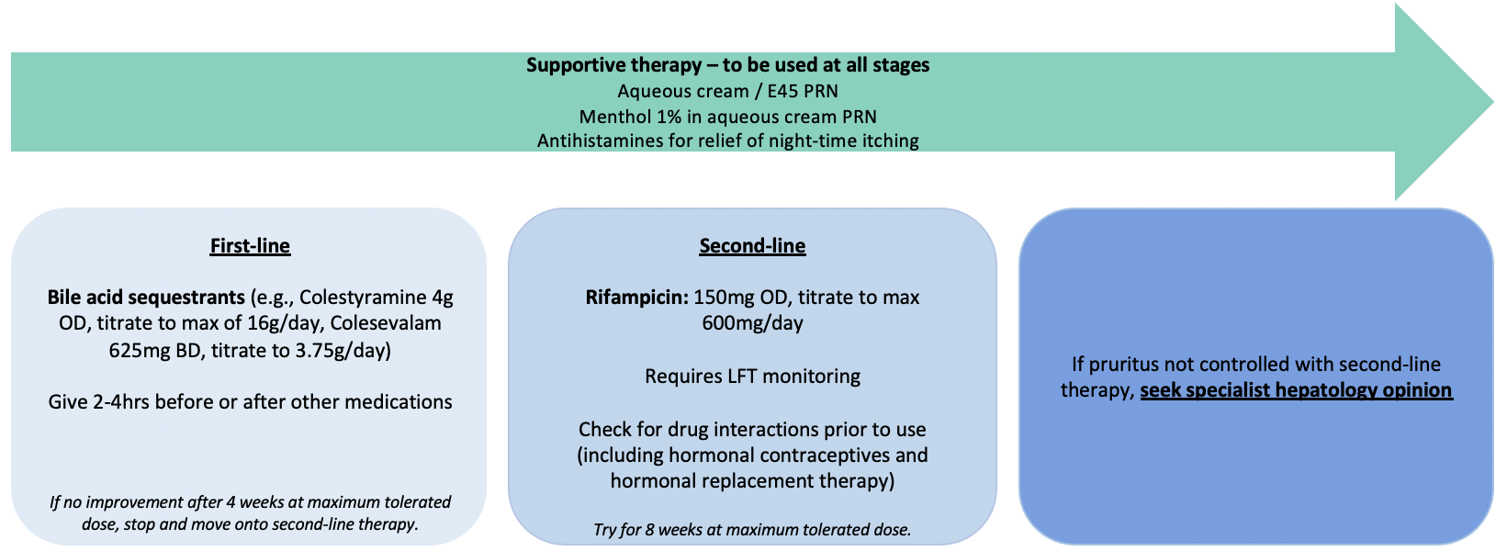

Pruritus:

Fatigue:
Modify exacerbating factors

- Screen for depression
- Screen for autonomic dysfunction
- Assess sleep hygiene

Treat direct contributors

- Ensure pruritus is treated to minimise sleep disturbance
- Screen for associated autoimmune disease (e.g., AIH, thyroid disease, B12 deficiency, Addison’s disease)
- Check for age-related conditions (e.g., diabetes, heart failure, renal failure)

Support

- Signpost patients to support groups
(e.g., PBC Foundation, British Liver Trust)

Lifestyle adjustments

- Recommend pacing strategies (using available energy to its best advantage) and timing strategies (arranging key tasks for earlier in the day).

Link to full BSG PBC Guidelines : https://www.bsg.org.uk/wp-content/uploads/2019/11/BSG-and-UKPBC-primary-biliary-cholangitis-treatment-and-management-guidelines.pdf

Sicca symptoms:
Dry eyes: artificial tears, lubricating eye ointment (night-time)
Dry mouth: good dental hygiene, sugar-free chewing gum and lozenges, artificial saliva
For refractory symptoms refer to specialist management (rheumatology/ophthalmology)

