Background
Supporting research by members to improve digestive and liver health is one of the core charitable objectives of the British Society of Gastroenterology. To this end, the BSG Research Committee aims to provide resources to members to conduct and participate in collaborative multicentre studies. Following feedback from membership, one of the challenges identified in conducting multicentre observational studies and audits was the lack of access to a data capture application. The administration and data governance are often barrier for researchers with limited funding for their research projects.
REDCap (Research Electronic Data Capture) is a secure, web-based application designed to support data capture for research studies, providing: 1) an intuitive interface for validated data entry, 2) audit trails for tracking data manipulation and export procedures, 3) automated export procedures for seamless data downloads to common statistical packages, and 4) procedures for importing data from external sources. The BSG has partnered with BiCOPS (Birmingham Centre for Observational and Prospective Studies) in providing support to BSG member researchers on a project-specific basis.
Aims
- To foster collaborative multicentre observational studies and impactful audits
- To promote multi-professional and collaborative network research between gastroenterologists, specialist Nurses, and Allied Health Care professionals
- To enable early career researchers to lead and collaborate in multicentre studies
- To provide BSG members with limited access to large scale grants to formulate and deliver on research ideas
Eligibility
- BSG membership for the lead applicant
- Multicentre project (minimum 10 centres)
- Project timeline for completion maximum 12 months
- The following are not eligible to apply
  - Single centre studies
  - Study funded in part or full by large funding bodies (like NIHR) or funders with AMRC membership
  - Industry funded studies
  - Studies using handling of existing data sets such as registry data sets

BSG support
The BSG will provide funding with BiCOPS to enable the researcher to support study conduct from set up, recruitment, and analysis and writing (details in figure 1 ). The support will be for a period of 12 months per project. The BSG will not be involved in the conduct or governance of the study, and this will be subject to data sharing agreements between the host institution and BiCOPS
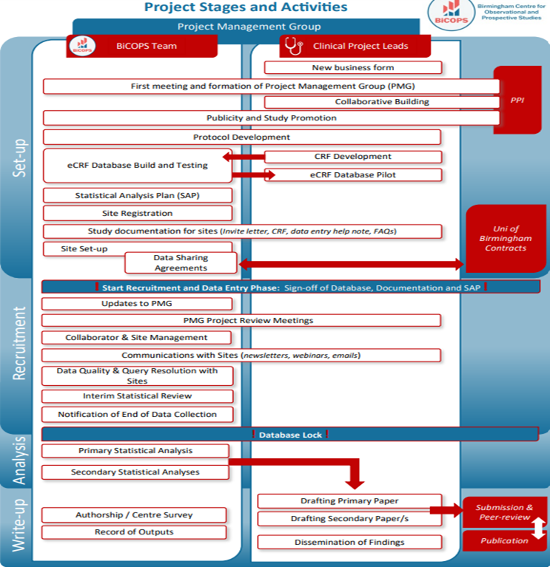
Selection Criteria
Essential
- Lead applicant has BSG membership and practicing within United Kingdom
- The study is observational in nature
- The study is multicentred involving participation of 10 or more centres
- Feasible to be completed within 12 months
- The study should be patient-oriented research awards. For the purposes of this support, patient-oriented research is defined as:
  - Research conducted to evaluate human data
  - Should have direct applicability to clinical care
  - Is of value to clinical care within NHS
  - Research on new diagnostic and therapeutic interventions which are already available for clinical use within NHS settings
Desirable
- Prospective studies preferred although high quality retrospective data collection with potential impact for clinical care will be considered
- Multi-professional collaborative involvement such as trainee networks, nursing networks
- Involvement of early career researchers
- Involvement of Allied Health Care Professionals such as nurses, AHPs, dieticians and other s
- Research proposals meeting research priorities of the BSG
- Co-funding available for the project
- Track record in delivery of multi-centre projects
Role of Host NHS organisation
Written confirmation is required from the employing organisation that they will sponsor the study and agreement or have MoA with BiCOPS for data sharing within the REDcap platform. Additionally, the research support application should be reviewed and approved by the manager with responsibility for research (e.g. Head of Research, Research Director or manager or equivalent) within the employing organisation.
Judging of applications
The judging committee will be chaired by the Chair of the BSG Research Committee and will have a lay trustee as a non-voting member. In addition, 4 other voting judges will be included in the judging panel meeting the EDI principles of the BSG.
Reviewers consider the following when scoring applications: relevance of study for clinical practice, feasibility, methodology, and prior track record of the applicant or collaborative network.
Progress Assessment
Progress will be monitored via the BSG Research Committee research support monitoring group through 3 monthly meetings and final appraisal and written report at completion of project. The applicants are strongly encouraged to submit the research outputs to BSG annual meetings and if an abstract related to your research project is selected for presentation, you may submit up to £500 in expenses (travel/accommodation) for reimbursement.
Research Priority Themes for 2022-2024 awards
- Pilot research into unmet needs identified in Priority Setting Partnership
- Research addressing inequality in GI healthcare
- Sustainability in Gastroenterology and Hepatology
- Application of novel technologies to improve patient care

